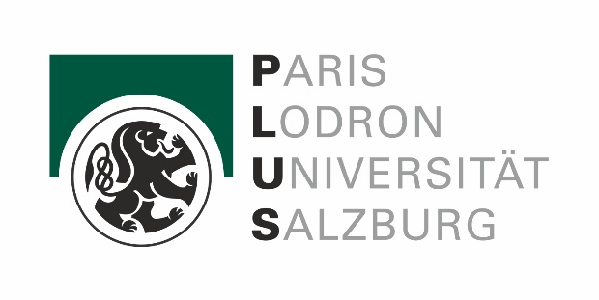
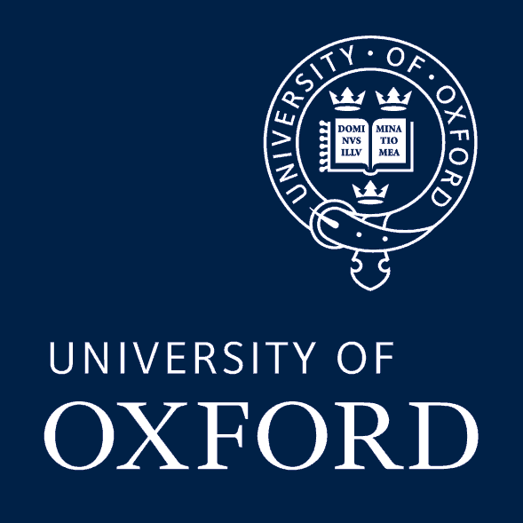
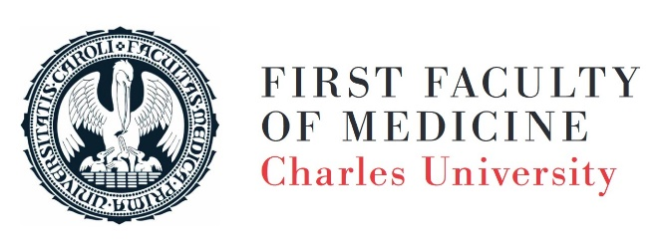

PREHISTORIC, ANCIENT AND MEDIEVAL MEDICINE: NEW PERSPECTIVES AND CHALLENGES FOR THE TWENTY-FIRST CENTURY
First Faculty of Medicine, Charles University, Prague
21st – 23rd September 2022

general programme:

Wednesday, 21st September (main conference hall)
13:30-14:00 Opening remarks
Session 1: Archaeology of Medicine and Charles University Projects
Chair: Hana Vymazalová
14:00-14:30 Tomas Alusik – Pavla Alusikova Dostalikova: Asklepieion of Paros Re-Study Project 2018-2022
14:30-15:00 Lucie Burešová: The benefits of a closer look: Traceology analysis of the La Tène Period and Roman Age surgical tools found in Central Europe
15:00-15:30 Rupert Breitwieser: Dealing with epidemics in antiquity: Social reactions and emotions
15:30-15:45 coffee break
15:45-16:15 Robert Arnott: Disease and healing in Hittite Anatolia: A critical review
16:15-16:45 Ieva Ancevska: Healing places in Latvian healing tradition: Throughout history and nowadays
16:45-17:30 Special evening lecture 1 – Václav Smrčka: Palaeopathological profile of Neolithic Lengyel Culture
17:30-18:00 discussion
Then informal meeting in the pub

Thursday 22nd September

Main conference hall:
Session 2: Prehistoric Aegean, Egyptian and Near Eastern Medicine
Chair: Robert Arnott
8:30-9:00 Brandelyn Andres: The maintenance of female sexual and reproductive health in the ancient Aegean

9:00-9:30 Christofilis Maggidis: The ‘House of the Idols’ at Mycenae: A Mycenaean shrine of healing and magic (online)
9:30-10:00 Veronika Sobotková: Diagnostic system in the medicine of ancient Mesopotamia

10:00-10:30 Letizia Savino: New studies on a Mesopotamian prescription against ‘Mountain Fever’

10:30-10:45 coffee break

10:45-11:15 Electra Apostola – Eirini Skaroglou: Herbal medicine in ancient Egypt: Skin disorders and treatment

11:15-11:45 Hana Vymazalová: Life after the Pyramid Age: Secondary burials at Djedkare's royal cemetery at Saqqara

11:45-12 discussion

Small conference hall:
Session 3: Medieval Medicine from Interdisciplinary Perspective
Chair: Claire Burridge
8:30-9:00 Efraim Lev: Arabic medicine and pharmacology as practiced by Jews in Medieval muslim lands (online)

9:00-9:30 Dimitra Makri – Ilias Nesseris: The treatment of ophthalmological diseases in the Byzantine world (online)
9:30-10:00 Matěj Gogola: New challenges for Slovak historiography of medieval medicine
10:00-10:30 Antonella Pedergnana – Roger Seiler – Renata Huber – Patrick Eppenberger: Oral health in early medieval Switzerland: the site of Baar-Früebergstrasse (ZG, Switzerland)

10:30-10:45 coffee break

10:45-11:15 Joshua T. Schnell: Medicinal dimensions of marketplace activity among the ancient Maya: A case study from Piedras Negras, Guatemala (online)
11:15-11:45 Robin Pánek: Hospitaller care of the Order of St. John in the Holy Land in the Medieval period

11:45-12 discussion

12-13:30 lunch 12-13:30 lunch

Main conference hall:
Session 4: Medicine in the Graeco-Roman World
Chair: Rupert Breitwieser
13:30-14:00 Velia Boecker: Healing places in the ancient world: So-called healing sanctuaries revisited. New perspectives on archaeological sites in Central Italy (4th – 1st cent. BC)
14:00-14:30 Judit Pásztókai-Szeőke: Dress to heal? Natural dyes and dye-plants as herbal remedies in the Roman times
14:30-15:00 Mark Beumer: From Asklepieion to Kosmidion? Temple sleep: A dynamic ritual in Late Antiquity
15:00-15:30 Jared J. Eddy: Nutrition and health in imperial Roman populations with implications for tuberculosis
15:30-15:45 coffee break
15:45-16:15 Athanasios Sideris: "You need to visit Antikyra": Healing Classical Madness (online)
16:15-16:45 Conan Doyle: Temperament and emotion: The physical causes of emotional distress in Late Latin medical theory
16:45-17:30 special evening lecture 2 – Claire Burridge: Books and Bodies: Interdisciplinary approaches to studying Early Medieval medicine
17:30-18 discussion

Friday 23rd September (main conference hall)
Session 5: Asklepios and Hippocratic-Galenic Medicine
Chair: Milena Melfi
8:30-9:00 Ariadne Klonizaki: The social impact of the cult of Asklepios in Greece (online)
9:00-9:30 Sascha Boelcke: Establishing a healing place: New thoughts on Tiber Island
9:30-10:00 Sylva Fischerová: An archaeology of temperaments, or from humours to four temperaments
10:00-10:30 Matyáš Havrda: Galen’s treatise On Demonstration: Research update
10:30-10:45 coffee break
10:45-11:15 Kyriakoula Manaridou – Charalambos Dokos: Life coaching in Graeco-Roman world: The foundations of modern philosophical psychotherapy and counselling
11:15-11:45 Tomáš Glomb: Was Asclepius more popular during the Antonine Plague? A quantitative evaluation of Latin inscriptions
11:45-12 discussion
12-13:30 lunch

Session 6: Medicine of Late Antiquity & Online Session
Chair: Tomas Alusik
13:30-14:00 Dimitra Makri: The medicinal uses of myrrh (Σμύρνα) in Late Antiquity (online)
14:00-14:30 Daniel Vaucher: The rhetorics of healing: Strategies of persuasion in three Late Antique healing prayers (online)
14:30-15:00 Vlastimil Drbal: Pilgrimage to the healing cults in the Near East and Egypt during the Late Antiquity (online)
15:00-15:15 coffee break

15:15-15:45 Anagnostis P. Agelarakis: Shanidar Cave in Iraqi Kurdistan: A sanctuary for medical treatment and healing for the injured and ailing members of its Neanderthal and Proto-Neolithic Homo Sapiens occupants (online)
15:45-16:15 Jonathan M. Flood - Rachel Dewan: The curative chemistry of healing water from Asklepeion in Sicily and Greece (online)
16:15-17:00 special evening lecture 3 – Milena Melfi: Cure and cult in the Asklepieion of Lebena (Crete)

17:00-18:15 Final discussion and closing remarks (Tomas Alusik, Robert Arnott, Rupert Breitwieser)
Symposium Dinner afterwards (18:45)

