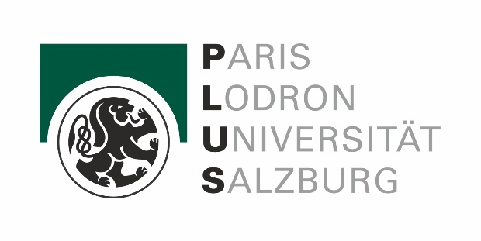
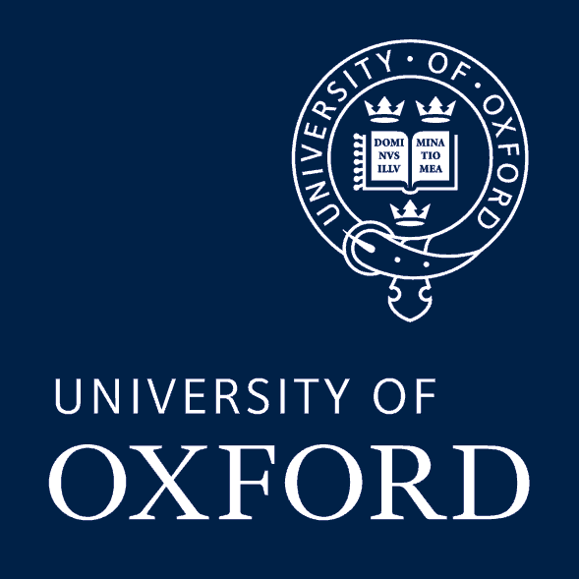
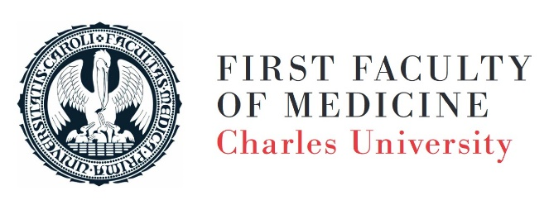

PREHISTORIC, ANCIENT AND MEDIEVAL MEDICINE: NEW PERSPECTIVES AND CHALLENGES FOR THE TWENTY-FIRST CENTURY

Institute for History of Medicine and Foreign Languages
First Faculty of Medicine
Charles University
U Nemocnice 4
Prague 2, Czech Republic
21st – 23rd September 2022

THIRD CIRCULAR

Dear colleagues,

This is to inform you that due to some last moment cancellations, the conference was shortened into three days only - Wednesday 21st to Friday 23rd September. The Saturday (24th Sept) programme was cancelled completely, and the papers had to be rearranged within some conference sessions. There are 34 papers and 3 keynote lectures on the agenda.
Check the new programme, please.

This shortening of the conference programme was the most reasonable solution, given the new facts and number of papers. The official part of the conference will thus end by the Symposium Dinner on Friday 23rd night, after the final discussion and concluding remarks.

In case of your interest, on Saturday (24th Sept) morning there will be an informal walk through the historic city of Prague, guided by me. We can discuss the details in person during the conference.

All information and important documents (revised and updated conference programme, book of abstracts and the list of participants & papers) will be uploaded very soon into the conference section of the Institute for History of Medicine and Foreign Languages web:
https://udl.lf1.cuni.cz/en/prehistoric-ancient-and-medieval-medicine-new-perspectives-and-challenges-for-the-twenty-first-century-21st-23rd-september-2022-copy

Thank you for your kind understanding and we are looking forward to meeting you soon in Prague!

With kind regards,

Tomas Alusik
Institute for History of Medicine and Foreign Languages, First Faculty of Medicine, Charles University
Professor Robert Arnott, University of Oxford
Dr. Rupert Breitwieser, University of Salzburg

